Сверло алмазное подковообразное

МСП
(тип 1-с коническим хвостовиком и резьбой 1/2",
тип 2- с цилиндрическим хвостовиком)

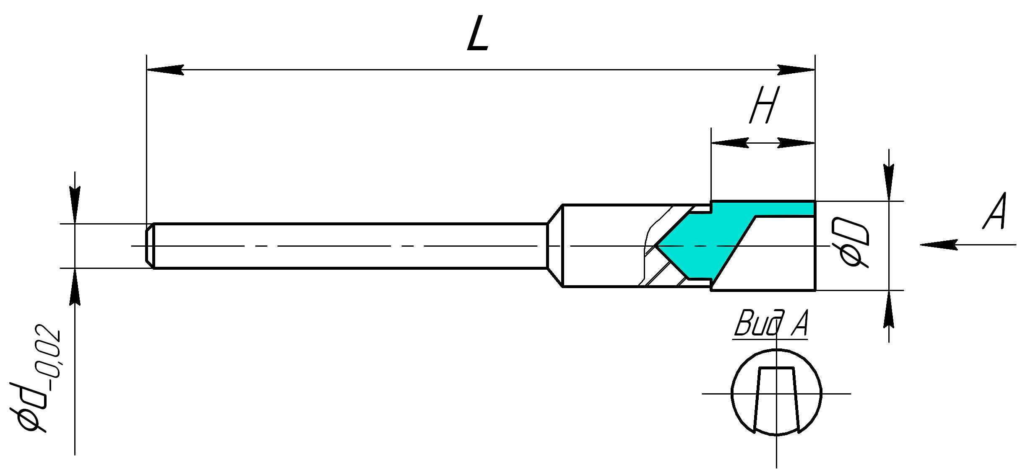
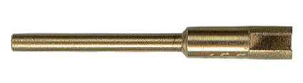
Обозначение | ØD  мм | H  мм | Ød  мм | L  мм
МСП 2-1,6-1,8 | 1,8 | 3,0 | 1,6 | 25,0
МСП 2-1,6-1,8* | 1,8 | 6,0 | 1,6 | 25,0
МСП 2-2,35-2,5* | 2,5 | 5,0 | 2,35 | 36,0
МСП 2-2,35-2,5 | 2,5 | 4,0 | 2,35 | 35,0
МСП 2-2,35-3 | 3,0 | 4,0 | 2,35 | 35,0
МСП 2-2,35-3* | 3,0 | 5,0 | 2,35 | 85,0
МСП 2-2,35-3,5* | 3,5 | 5,0 | 2,35 | 45,0
МСП 2-2,35-3,5 | 3,5 | 4,0 | 2,35 | 35,0
МСП 2-2,35-4 | 4,0 | 4,0 | 2,35 | 35,0
МСП 2-2,35-4,5 | 4,5 | 4,0 | 2,35 | 35,0
МСП 2-2,35-5 | 5,0 | 4,0 | 2,35 | 35,0
МСП 2-3,0- 3,2* | 3,2 | 7,0 | 3,0 | 70,0
МСП 2-3,0-3,2 | 3,2 | 7,0 | 3,0 | 45,0
МСП 2-3,0-3,4 | 3,4 | 7,0 | 3,0 | 45,0
МСП 2-3,0-3,5* | 3,5 | 5,0 | 3,0 | 85,0
МСП 2-3,0-3,5 | 3,5 | 7,0 | 3,0 | 45,0
МСП 2-3,0-3,6 | 3,6 | 7,0 | 3,0 | 45,0
МСП 2-3,0-3,8 | 3,8 | 7,0 | 3,0 | 45,0
МСП 2-3,0-4,0 | 4,0 | 5,0 | 3,0 | 60,0
МСП 2-3,0-4* | 4,0 | 7,0 | 3,0 | 70,0
МСП 2-3,0-4,2 | 4,2 | 7,0 | 3,0 | 45,0
МСП 2-3,0-5,5 | 5,5 | 7,0 | 3,0 | 45,0
МСП 2-5,0-5 | 5,0 | 7,0 | 5,0 | 45,0
МСП 2-5,0-5,5 | 5,5 | 5,0 | 5,0 | 40,0
МСП 2-6,0-3 | 3,0 | 7,0 | 6,0 | 45,0
МСП 2-6,0-3,4 | 3,4 | 7,0 | 6,0 | 45,0
МСП 2-6,0-3,5 | 3,5 | 7,0 | 6,0 | 45,0
МСП 2-6,0-3,6 | 3,6 | 7,0 | 6,0 | 45,0
МСП 2-6,0-4,5 | 4,5 | 7,0 | 6,0 | 45,0
МСП 2-6,0-5 | 5,0 | 7,0 | 6,0 | 45,0
МСП 2-6,0-6 | 6,0 | 7,0 | 6,0 | 45,0
МСП 2-8,0-8 | 8,0 | 6,0 | 8,0 | 60,0
МСП 1-8 | 8,0 | 6,0 | G1/2-A | 75,0

