Круги алмазные профильные МКП

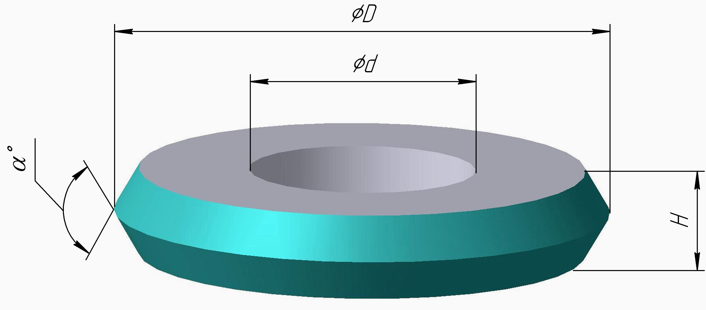
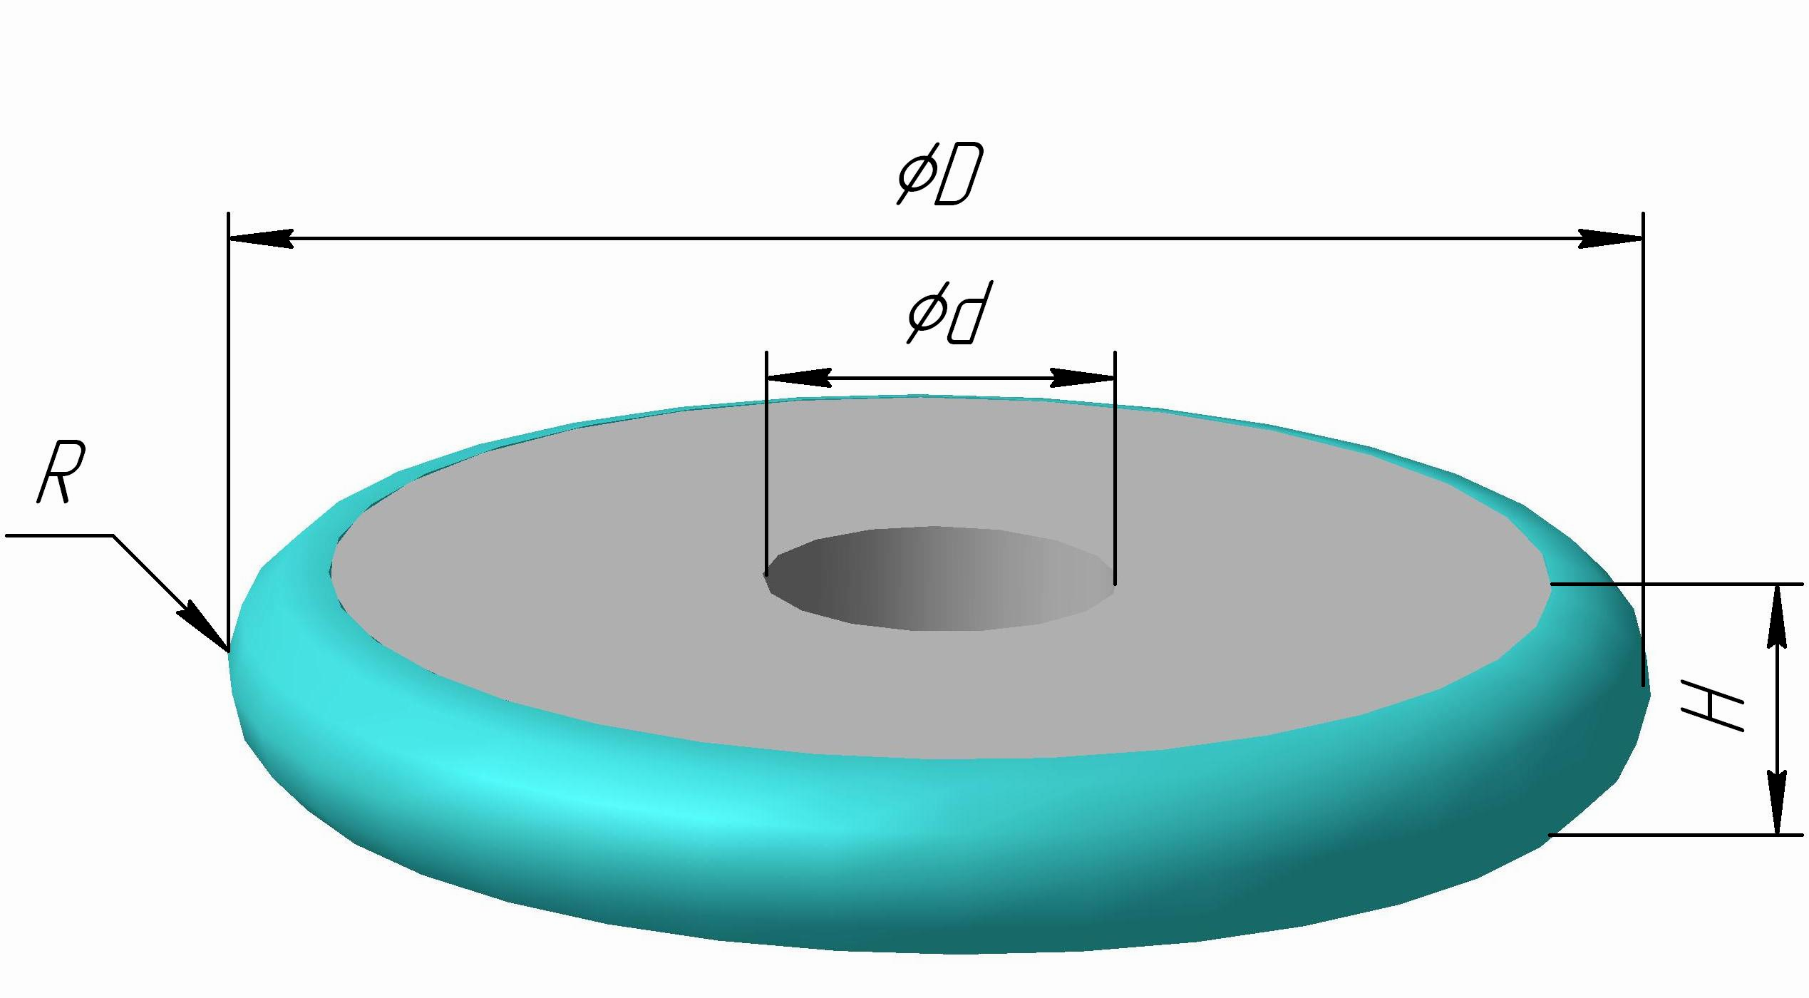

ØD  мм | H  мм | α ° | R  мм | Ød  мм
30,0 | 3,0 | - | 1,5 | 12,0
40,0 | 2,0 | 60 | - | 14,0
50,0 | 3,0 | 30 | - | 20,0
50,0 | 3,0 | 45 | - | 20,0
50,0 | 3,0 | 60 | - | 20,0
50,0 | 3,0 | 75 | - | 20,0
50,0 | 3,0 | 90 | - | 20,0
50,0 | 10,0 | 90 | - | 20,0
50,0 | 3,0 | - | 1,5 | 20,0
50,0 | 4,0 | - | 2,0 | 20,0
50,0 | 5,0 | - | 2,5 | 20,0
50,0 | 6,0 | - | 3,0 | 20,0
50,0 | 7,0 | - | 3,5 | 20,0
65,0 | 10,0 | 90 | - | 20,0
70,0 | 12,0 | 120 | - | 32,0

