Круги алмазные прямые (цилиндрические)
МКЦ
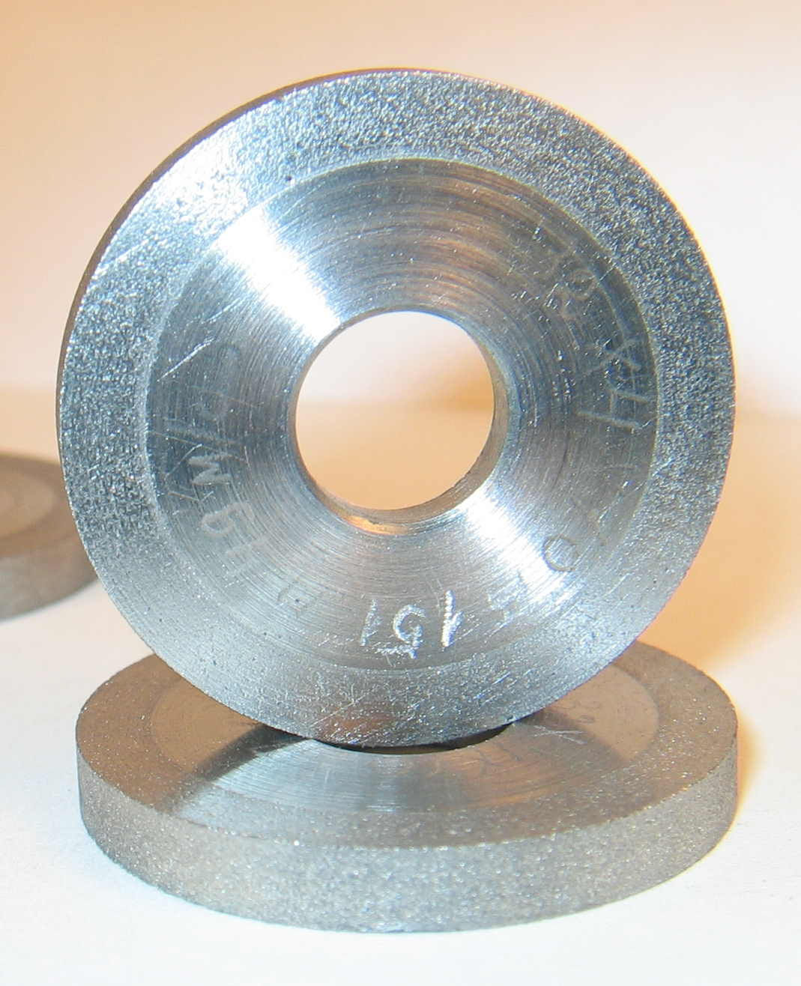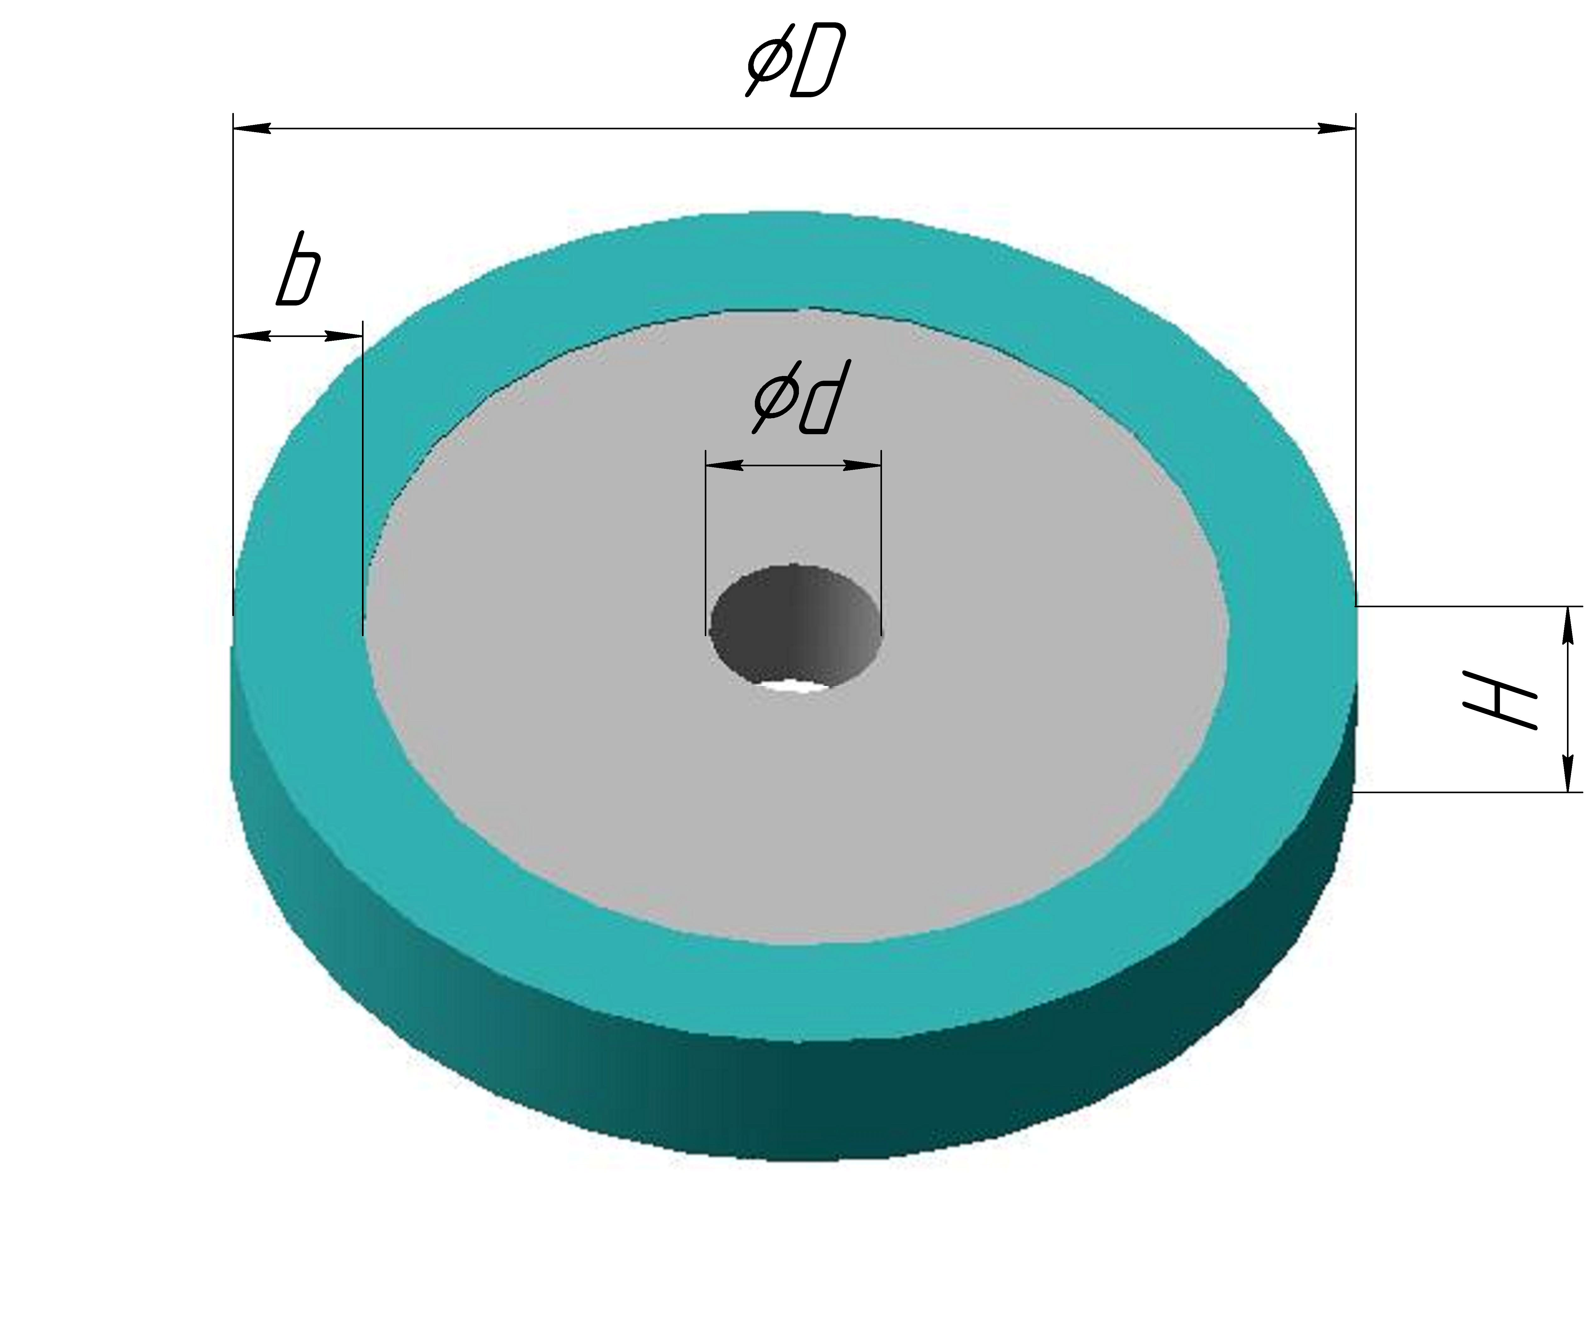

Обозначение | ØD  мм | H  мм | Ød  мм | b  мм
МКЦ 13х10х4 | 13,0 | 10,0 | 4,0 | 2,0
МКЦ 15х5х5 | 15,0 | 5,0 | 5,0 | 2,0
МКЦ 16х5х6 | 16,0 | 5,0 | 6,0 | 2,0
МКЦ 16х16х6 | 16,0 | 16,0 | 6,0 | 2,0
МКЦ 20х10х7 | 20,0 | 10,0 | 7,0 | 1,5
МКЦ 20х5х10 | 20,0 | 5,0 | 10,0 | 2,0
МКЦ 20х20х6 | 20,0 | 20,0 | 6,0 | 2,0
МКЦ 20х25х6 | 20,0 | 25,0 | 6,0 | 1,5
МКЦ 25х5х6 | 25,0 | 5,0 | 6,0 | 2,0
МКЦ 25х15х10 | 25,0 | 15,0 | 10,0 | 2,0
МКЦ 26х30х16 | 20,0 | 30,0 | 16,0 | 3,0
МКЦ 30х30х10 | 30,0 | 30,0 | 10,0 | 2,0
МКЦ 30х5х20 | 30,0 | 5,0 | 20,0 | 2,0
МКЦ 32х4х10 | 32,0 | 4,0 | 10,0 | 3,5
МКЦ 35х3,5х6 | 35,0 | 3,5 | 6,0 | 2,0
МКЦ 35х4х10 | 35,0 | 4,0 | 10,0 | 2,0
МКЦ 40х5х16 | 40,0 | 5,0 | 16,0 | 3,0
МКЦ 40х5х20 | 40,0 | 5,0 | 20,0 | 2,0
МКЦ 41,7х10х14 | 41,7 | 10,0 | 14,0 | 2,0
МКЦ 50х50х16 | 50,0 | 50,0 | 16,0 | 4,0
МКЦ 60х6х32 | 60,0 | 6,0 | 32,0 | 2,0

